Name__________________________________Date______________________________Hour_____________
Intermolecular Forces Webquest

Objective: The purpose of this webquest is to achieve the following:
- An understanding of what intermolecular forces are
- Descriptions of the three (3) types of intermolecular forces
- Understand how intermolecular forces are related to states of matter.

Introduction: I want you to think of all the different kinds of relationships you have with people in your life. Take a moment and write down 3: ___________________ , _______________________ , ______________________

Now some of those relationships are stronger than others based on factors such as time you’ve known the person and experiences you’ve shared. Please rank those relationships mentioned above in order of strongest to weakest:
___________________ , _______________________ , ______________________

If we think about all of the people we come into contact with in our lives, some people we experience a strong bond with while others we experience a weaker bond with, and a lot of it depends on our personality and how it “meshes” with their personality. In the same way, molecules experience bonds or “relationships” with other molecules, and some of those bonds are stronger than others. That is what we will discover in this webquest.

Part 1: Introduction to Intermolecular Forces

http://chemed.chem.purdue.edu/genchem/topicreview/bp/intermol/intermol.html

- What is the difference between intramolecular and intermolecular?

- Which type of bond is stronger: intramolecular or intermolecular?

- How much energy does it take to break the H-O bond within water?

- How much energy does it take to break the bonds between water molecules?

- What is the difference between solids, liquids, and gases based on?

- What state of matter are substances with strong intermolecular bonds?

- What are Van Der Waals forces?

- List the three types of Van Der Waals forces?

Force #1 – Dispersion Force

https://www.chem.purdue.edu/gchelp/liquids/disperse.html

- Define dispersion force

- Draw pictures with labels demonstrating dispersion force.

- Explain your pictures in a few sentences

- What types of molecules exhibit this force?

- What is the relative strength of force as compared to other forces?

- What trends can change how strong the force is?

Force #2 – Dipole-Dipole Force

Watch the following video: https://www.youtube.com/watch?v=cERb1d6J4-M

- Define dipole-dipole force

- Draw pictures with labels demonstrating dipole-dipole force.

- Explain your pictures in a few sentences

- What types of molecules exhibit this force?

- What is the relative strength of force as compared to other forces?

- What trends can change how strong the force is?

Force #3 – Hydrogen Bonding

Go to: https://chemfiesta.org/2015/03/17/intermolecular-forces/

- Define hydrogen bonding

- Draw pictures with labels demonstrating hydrogen bonding.

- Explain your pictures in a few sentences

- What types of molecules exhibit this force?

- What is the relative strength of force as compared to other forces?

- What trends can change how strong the force is?

- Which three elements are necessary for hydrogen bonding to occur?

Intermolecular Forces and How they Affect Properties of Compounds

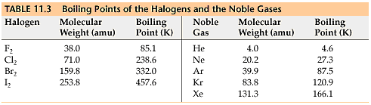
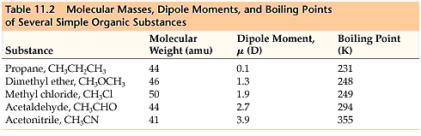
Some background information first. The dipole moment is a measurement of how polar a molecule is. The larger the dipole moment, the more polar the molecule is.

- Do you notice a trend in molecular weight in relation to boiling point? If yes, describe what is happening. If no, explain using data.

- Do you notice a trend in boiling point in reaction to magnitude of dipole moment? If yes, describe what is happening. If no, explain why no trend is observed?

- What intermolecular forces would be present in the halogens? Which would be present in the noble gases?

- Looking at just the noble gases and the halogens, write a statement describing the relationship between molar mass and boiling point.

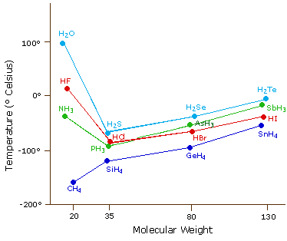

- Each line on the graph represents a period or a group. Which is it?

- Which compounds on the graph would exhibit hydrogen bonding forces?

- What happens to the boiling point of compounds exhibiting hydrogen bonding forces compared to similar compounds in the same family?
Review Time – What Have You Learned?

Rank the 3 intermolecular forces from weakest to strongest.
_____________________ < ________________________ < ________________________

Below are listed compounds. I want you to imagine you had a container of these compounds. For EACH compound, I want you to determine what force(s) would be present and why. Let’s do an example:

Suppose I had a container of CO₂. Right away I know it has LD forces because all atoms/molecules have LD forces. Next, I check if it’s polar. Even though the bond between Carbon and Oxygen is polar, the compound itself is non polar, and therefore cannot have dipole-dipole forces. And if it cannot have dipole-dipole forces, there is not possibility for it to have hydrogen bonding (especially since there is NO hydrogen!)

For each of the following identify the types of IMF’s present. You must complete a Lewis Dot Structure to determine the answer.

- O₂
- HF
- NH₃
- CH₄
- CO₂
- CH₃CH₂CH₃
- HCN
- CH₃Cl
- CO
- CH₃CH₂CH₂OH

