Physical Science Atomic Structure Notes

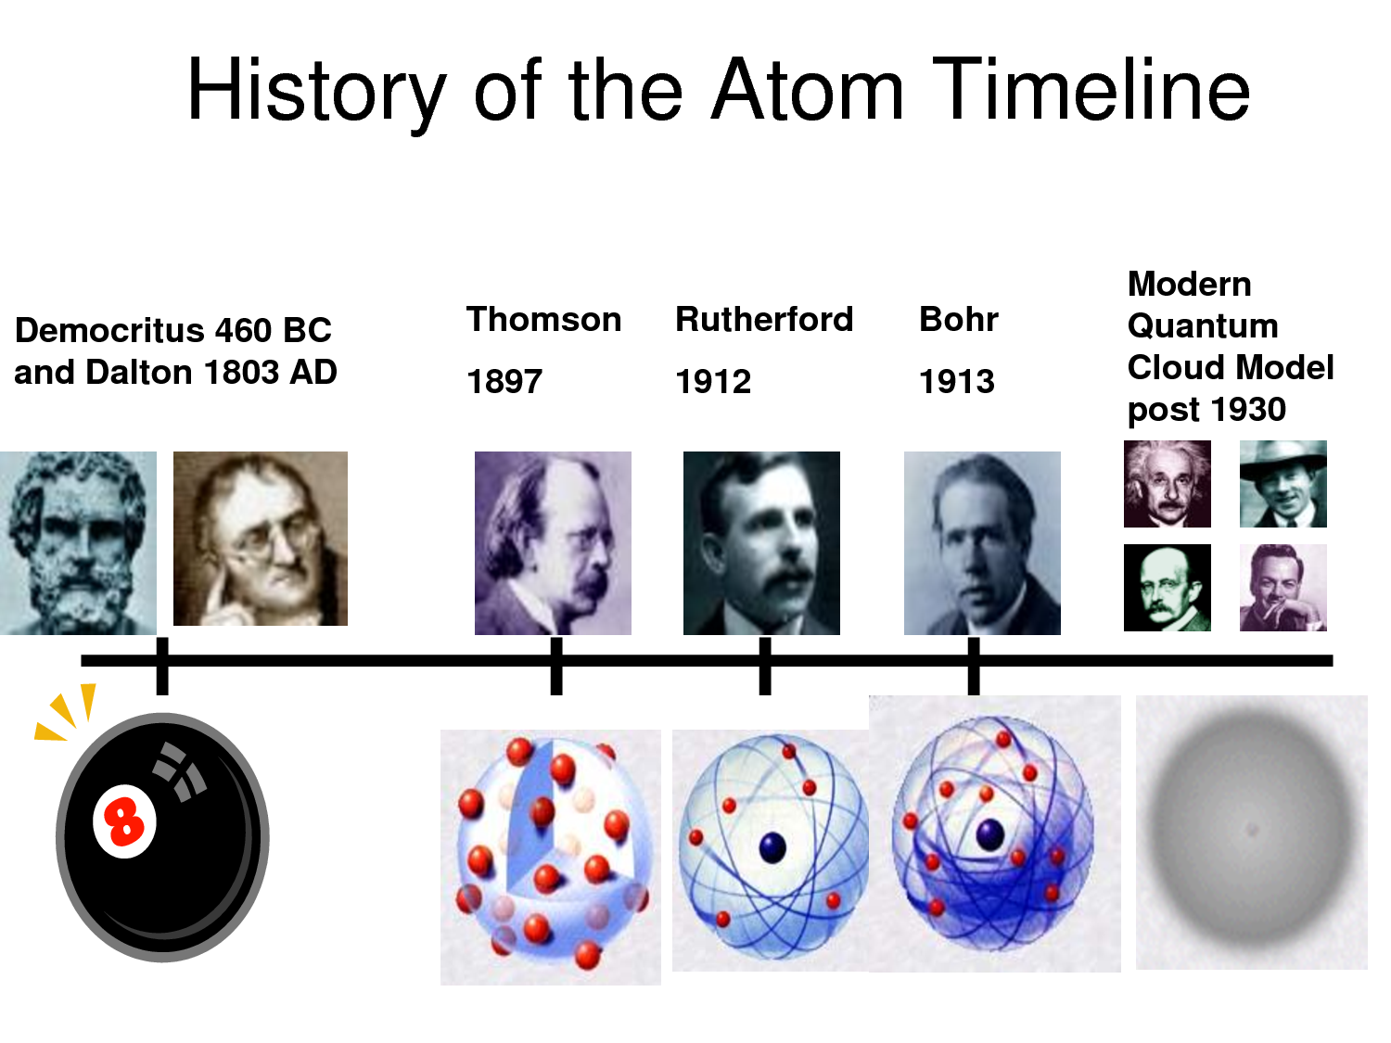

Dalton: _____________________________________________________________________

Thomson: ___________________________________________________________________

Rutherford: _________________________________________________________________

Bohr: ______________________________________________________________________

Quantum Model (Shroedinger): _________________________________________________

**Subatomic Particles**



**Atomic Number and Mass Number**

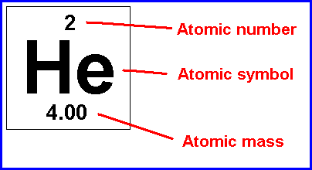Atomic Number: _____________________________

___________________________________________

Atomic Mass: _______________________________

___________________________________________

Isotope: ___________________________________

___________________________________________

**Bohr Model**

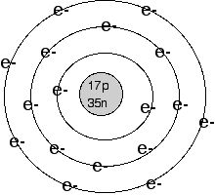This is a model of ________________

Energy levels are: ____________________________________

An electron moves between energy levels by _______________

____________________________________________________

When an electron moves down an energy level, ______________

Is produced.

Electron Cloud Model

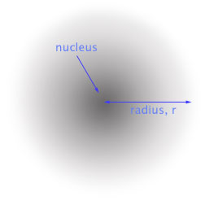The electron cloud model describes: __________________

________________________________________________

Atomic Orbital : _________________________________

________________________________________________

Electron Configurations: ____________________________

________________________________________________

Ground state is: ___________________________________

_________________________________________________

Vocabulary:

Nucleus Bohr model

Proton Average atomic mass

Electron isotope

Atomic number energy levels

Mass number electron cloud

Orbital electron configuration